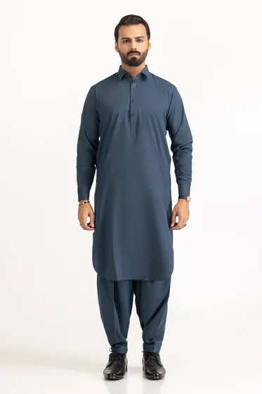[**PRODUCT DETAILS**](https://www.gulahmedshop.com/karandi-unstitched-fabric-karandi-lf#description)

Craft your wardrobe of essentials with the finest fabrics of GulAhmed Men’s Collection.

* Premium Quality Blended Fabric Polyester 80% & Silk 20%
* 7 MTR Suit Width 35 in

|  |  |
| --- | --- |
| More Information | |
| **NEW ARRIVALS:** | No |
| **GENDER:** | Men |
| **DISCOUNT PERCENTAGE:** | 31% to 40% |
| **SHIRT FABRIC:** | Wash & Wear |

SKU

MEN-FABRIC-298689 -P

IN STOCK

PKR 5,166